Leaksmy Heng

CS5330

Feb 07, 2025

Project 2

Report

**Short Summary of Overall Project**

I find this project incredibly challenging but enjoyable. Starting from the first task, I set up the pipeline to ensure that it accepts all 5 arguments, then I have to decide the approach to implement overall project. On top of that, I had to do research and review the class material to ensure that I understood each of the features and distance metrics before I code it up. Then there is the coding part which is also difficult because I am not used to c++. Despite all that, I find it enjoyable as the project’s instructions were cleared. Each task is kind of build on top of each other (like histogram and multi-histogram feature), which make it challenging, yet also nice cause I could reuse the previous code. At the end I can compare my result with the answers’ on the instructions to ensure that I am on the right track. In summary, the project is challenging but enjoyable.

**Short Reflection of What You Learned**

At the end of the project, I could say that I now have a better understanding of Content Based Image Retrieval. I can implement baseline matching feature extraction, histogram, multi-histogram and DNN. I also developed different distance metrics to make a comparison between target and feature image. I am happy with the progress I have made, even though sometimes I am stuck in the questions for a bit.

**Required Image**

1. Baseline Matching

Here we have an image, and we extract 7x7 square in the middle of the image as a feature vector. Then we used sum-of-squared-difference as the distance metric to compare the target image with the images in Olympus folder. The result of the distance metric calculation in stored in a map (dictionary) and sort it in ascending order of the distance. The smallest number means its best match to the target image.

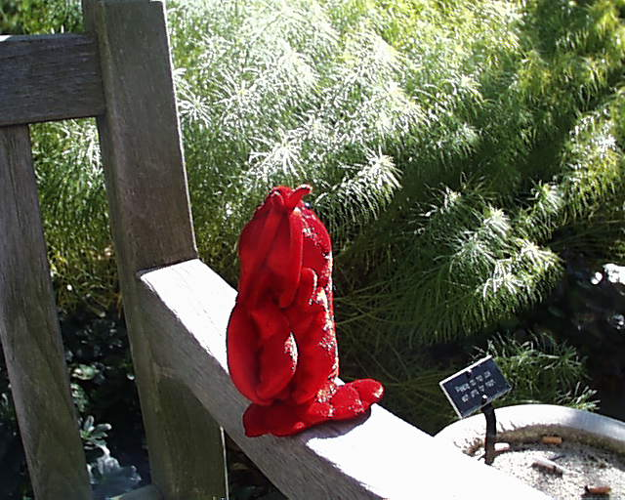Target Image pic.1016.jpg

Top 3 matches of pic.1016.jpg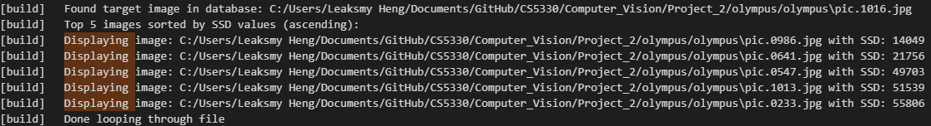

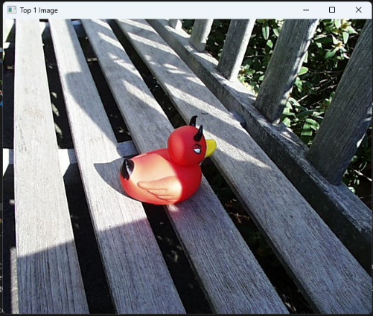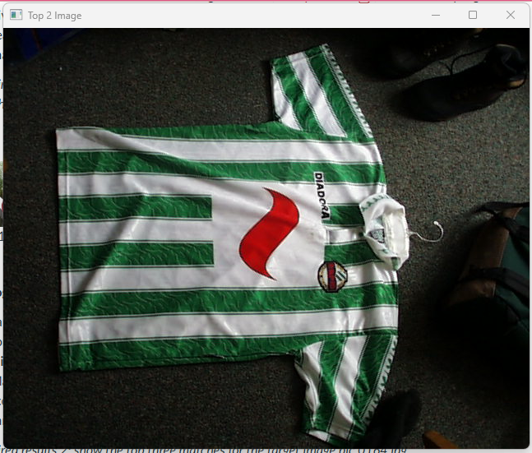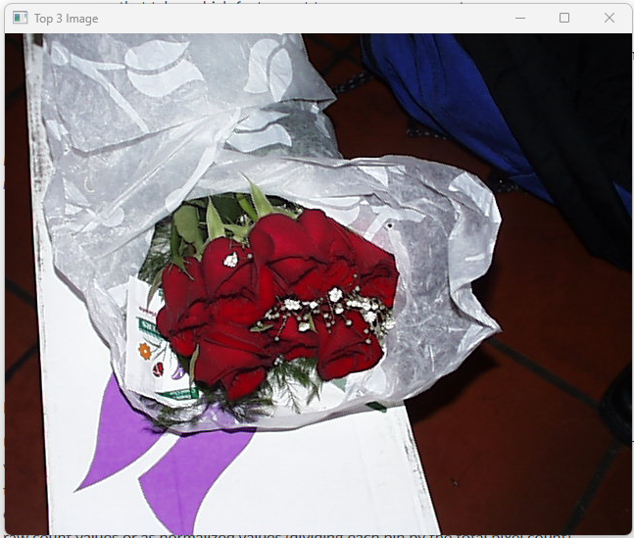

1. Histogram Matching

Here we have the image; we extracted the feature using a 3D color histogram. Each image in the database image is extracted using the same feature and then the histogram intersection method applies to compare the images in the database image with the target image. Each of the 3D-color histogram have 8 bins in this implementation.

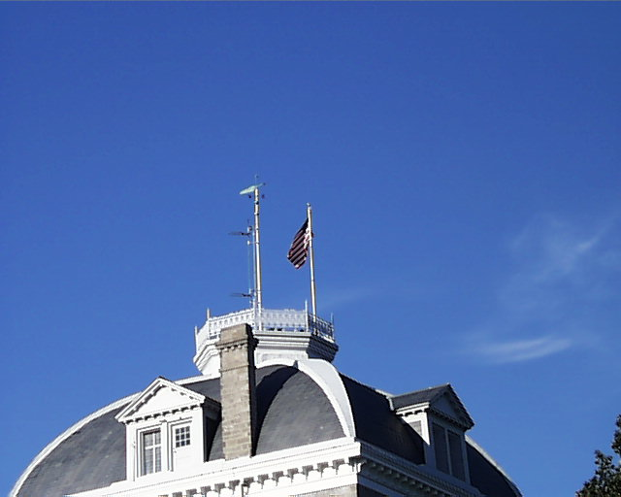Target Image pic.0164.jpg

Top 3 Matches of pic.0164.jpg

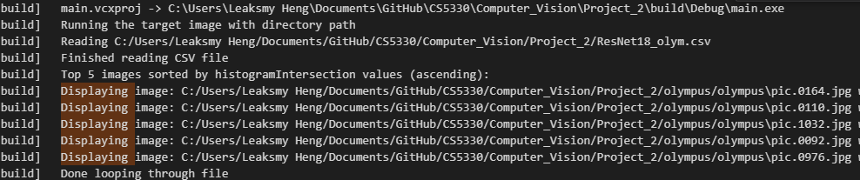

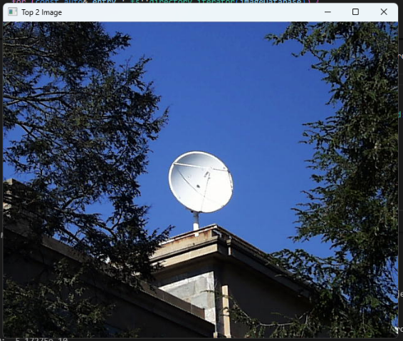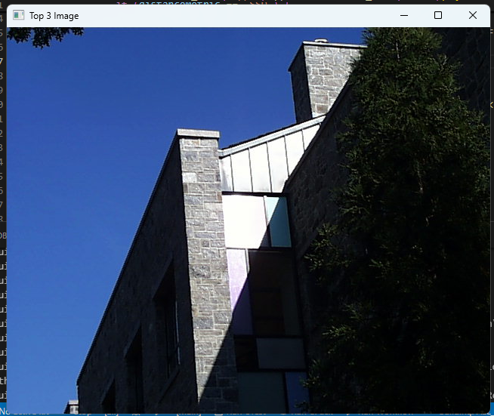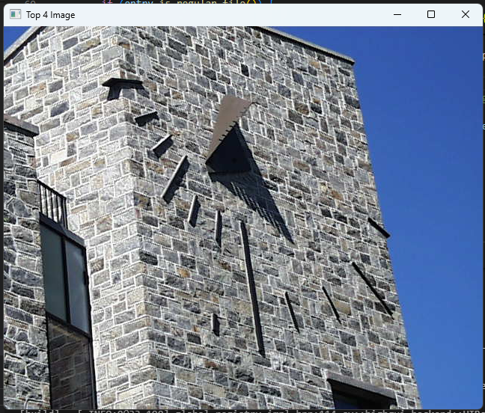

1. Multi-histogram Matching:

In this feature, I split the image into 2, top half and bottom half using cv::rect function. After that, I applied the histogram matching feature from task 2 to the top half and bottom half of the image. Therefore, now I got 2 3D-histogram of the images. I concatenate the 2 3D-histogram into 1 then I normalized the histogram using L1 to ensure the range is between 0 and 1. Histogram intersection is apply between the target image and the feature images.

Target Image pic.0274.jpg

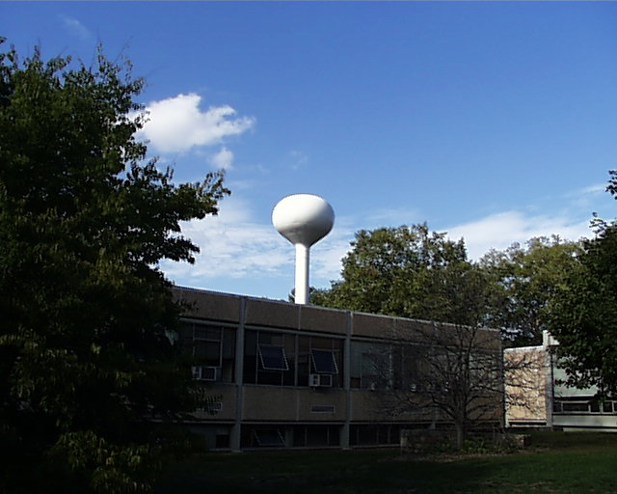

Top Three Matches of pic.0274.jpg

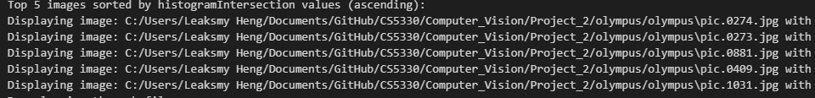

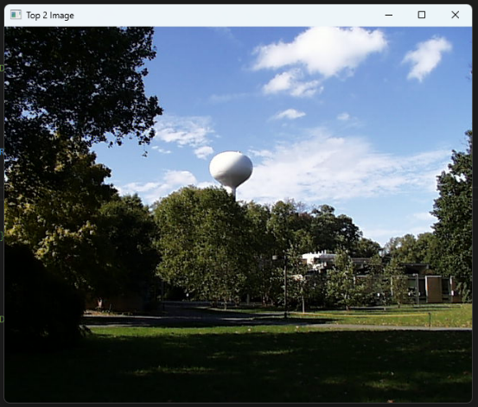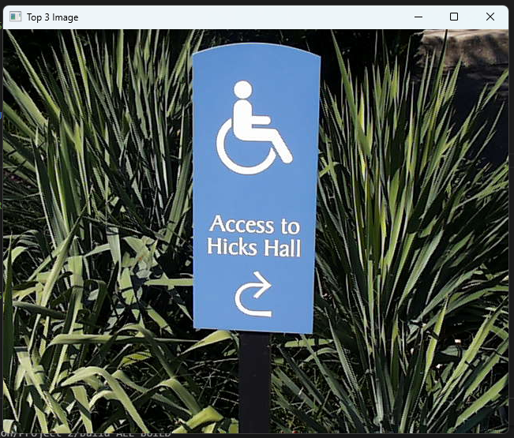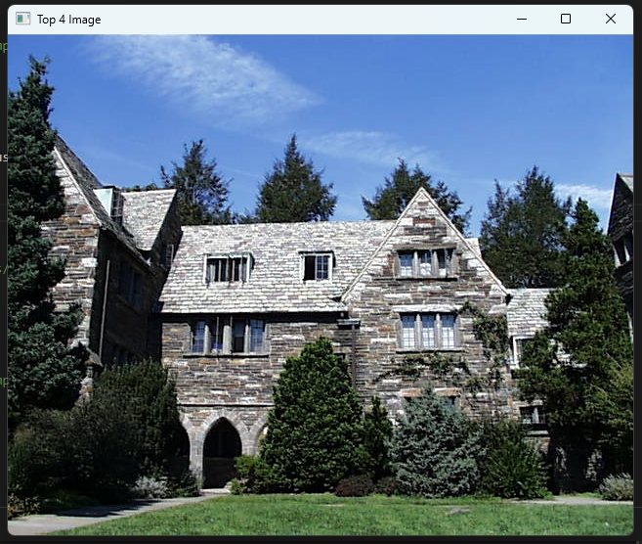

1. Texture and Color

In here, we combine color and texture as feature vector. For texture feature, I used gradient magnitude which we had done for the first project. Once I had that, I made 1D histogram out of it. I then reshaped my 3D color histogram to a 1D color histogram, so that both feature histograms are in 1D. I was thinking of merging the 2 histograms, but I am not entirely sure if that would ensure equal weighting when we use the distance metrics on it later on. Therefore, I decided to not merge the 2. I used chi-square distance on both the color and texture feature. Then apply weighted distance on both by having the chi-square result of both features multiply with 0.5 and sum with one another.

Target Image pic.0535.jpg

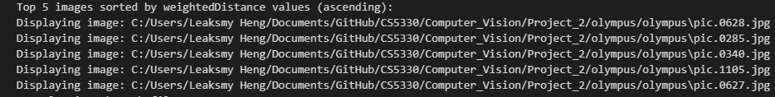Top Three Matches for The Target Image pic.0535.jpg

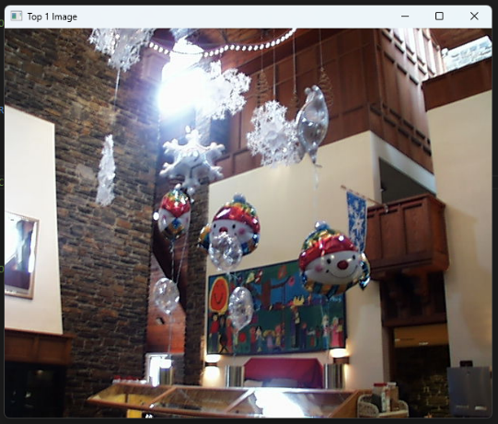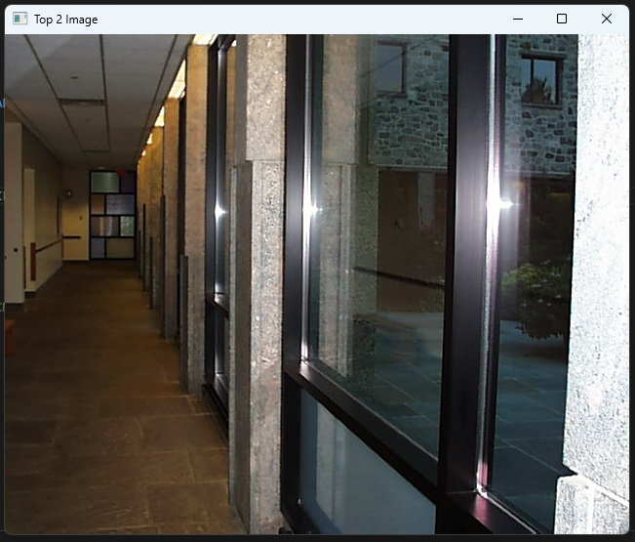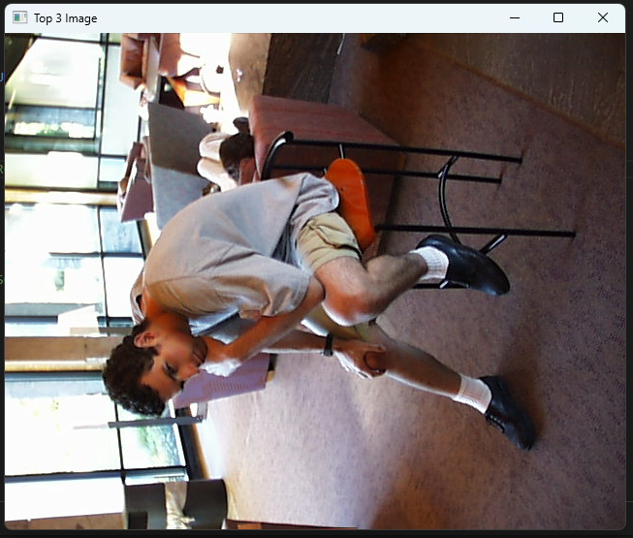

1. Deep Network Embeddings

This task is different from the previous tasks because rather than extracting the image directly from the image, I utilize the feature vector contain in the csv file that the professor provided. I use the SSD as a distance metric in this task.

Below is the two target images compared to the first 4 methods on top.

Target Image pic.0893.jpg Target Image pic.0164.jpg

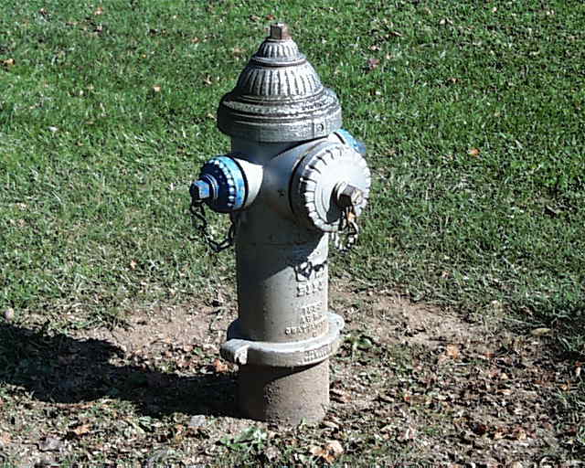

Top 3 Matches for Target Image pic.0893.jpg

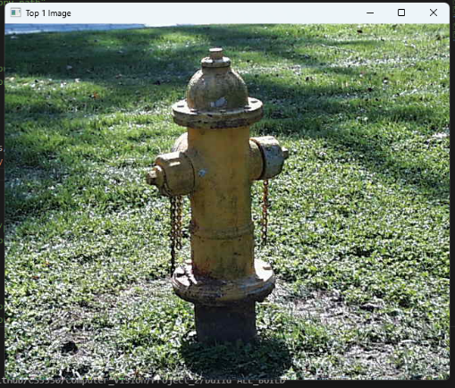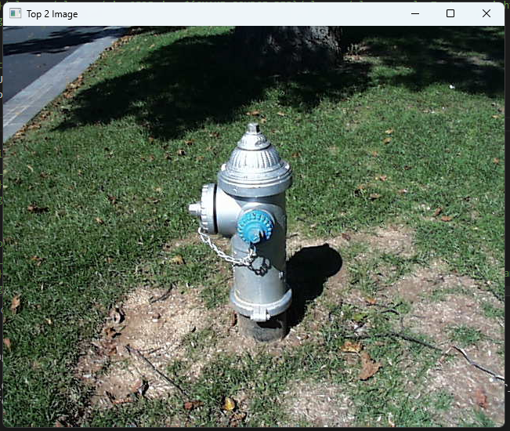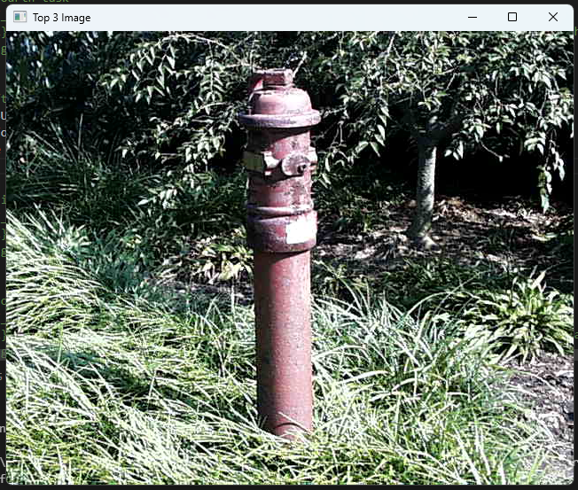

Using DNN

Using Baseline SSD

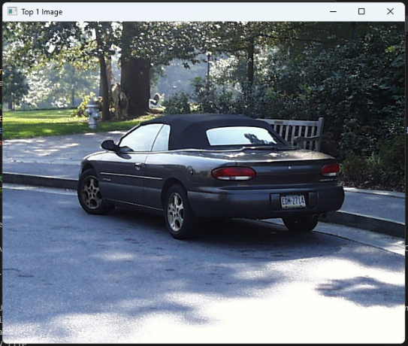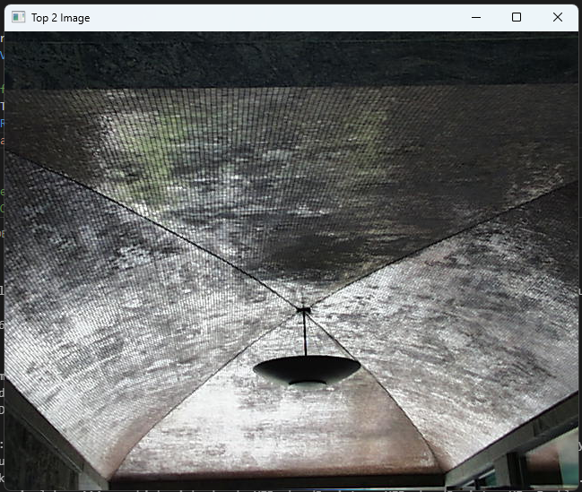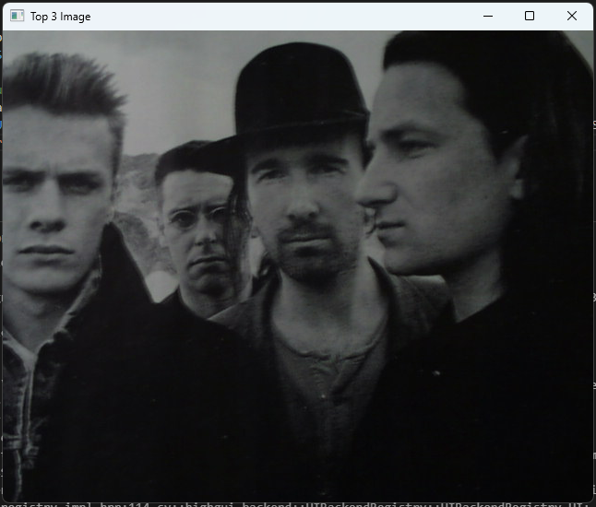

Using Histogram with Histogram Intersection Metric

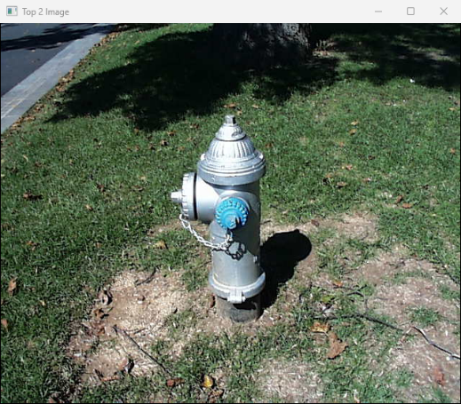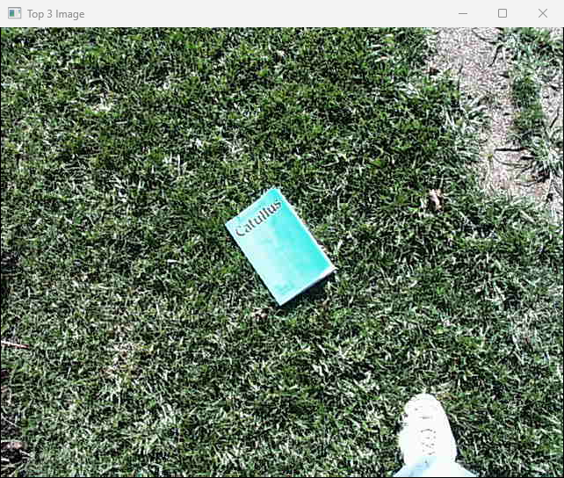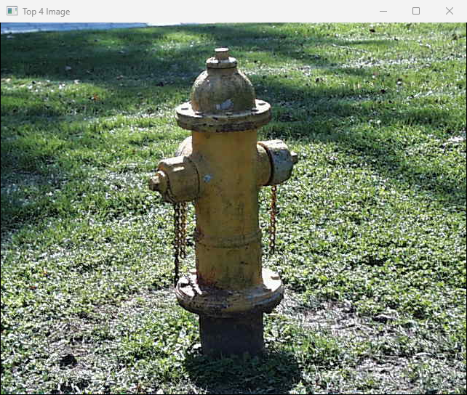

Using Multi-Histogram with Histogram Intersection Metric

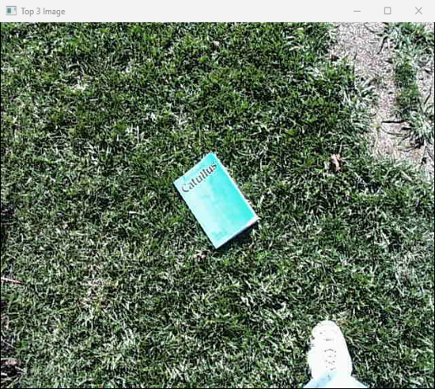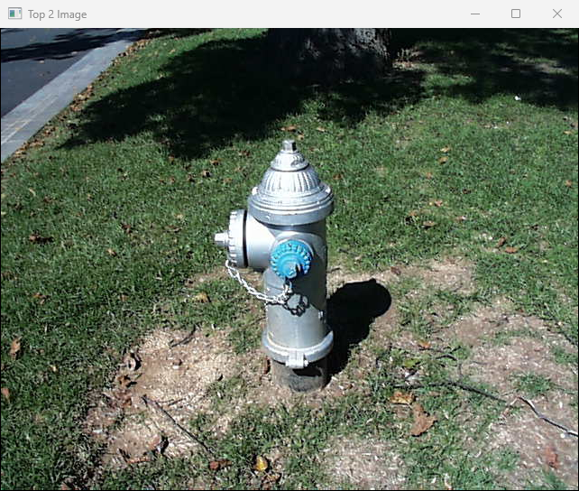

Using Color Texture with Weighted Distance (Chi-Square)

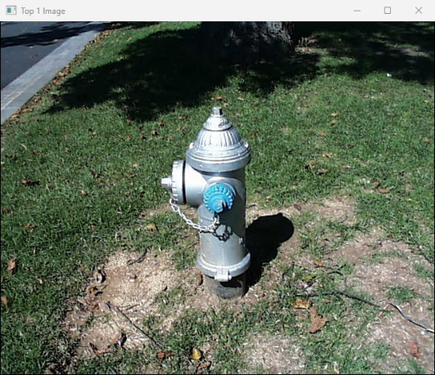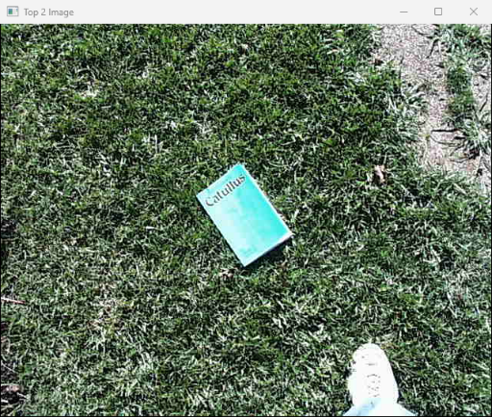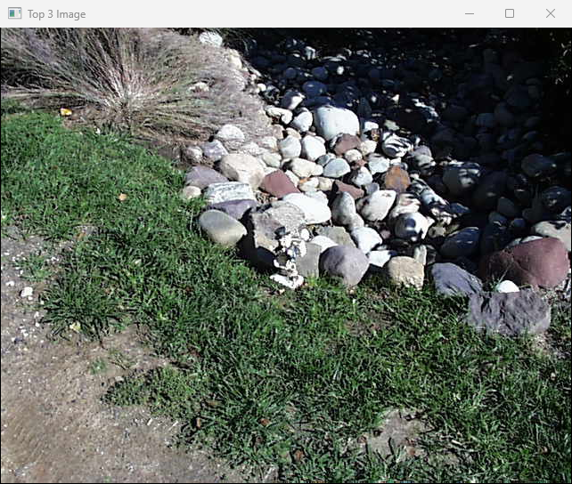

Top 3 Matches for Target Image pic.0164.jpg

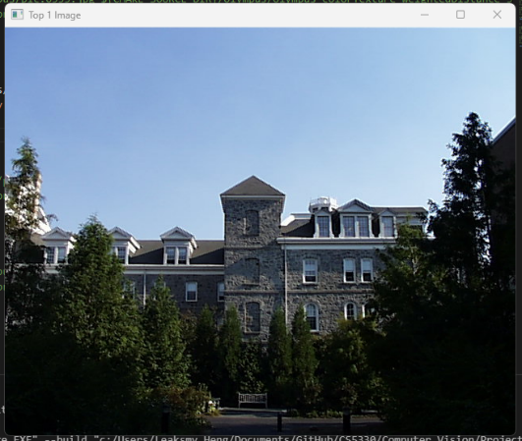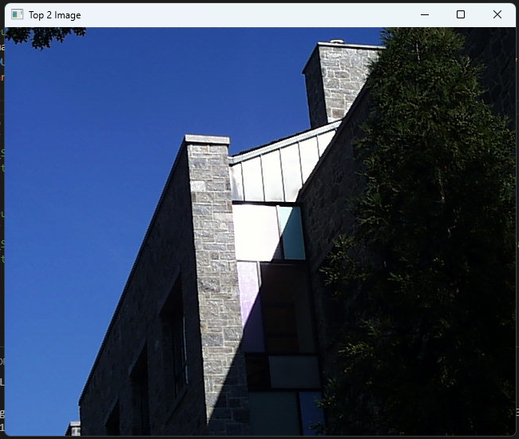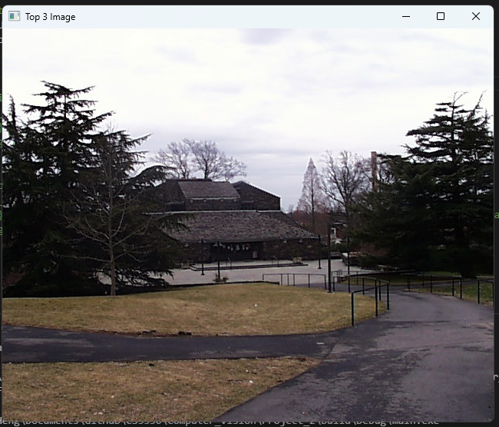

Using DNN



Using Baseline SSD

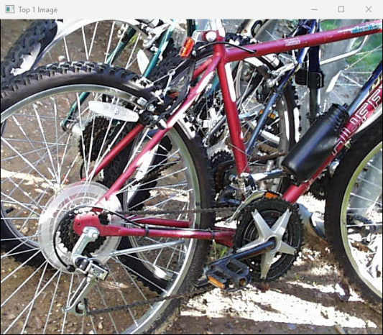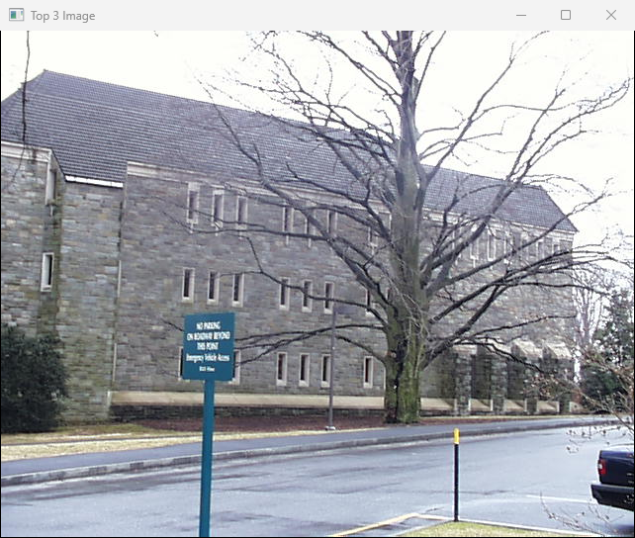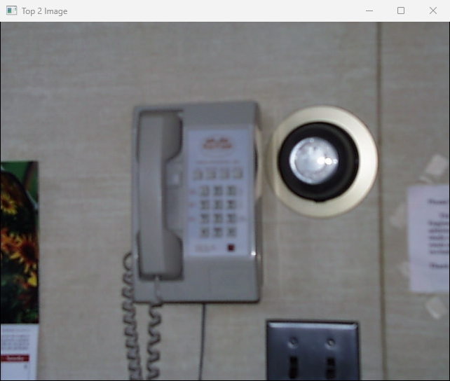

Using Histogram with Histogram Intersection

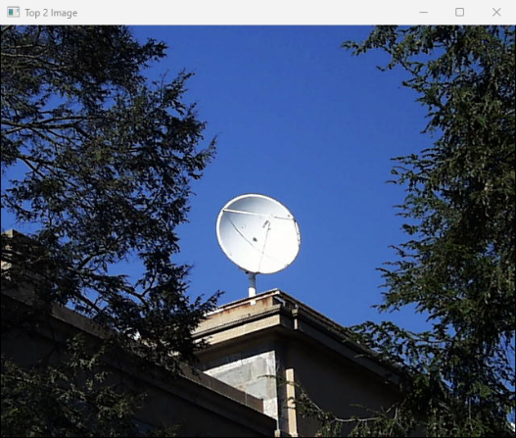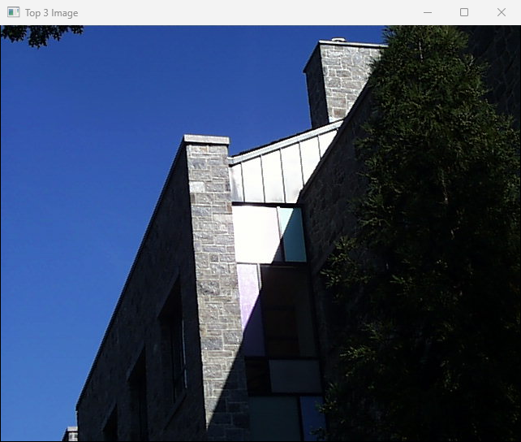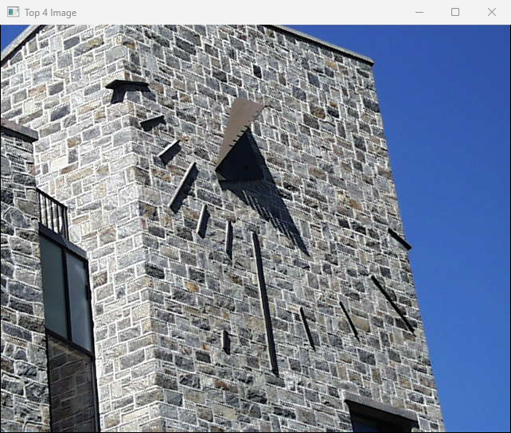

Using Multi-Histogram with Histogram Intersection



Using Color Texture with Weighted Distance (Chi-Square)



1. **Compare DNN Embeddings and Classic Features**

DNN embedding are not always better than classic features like histogram feature. Histogram feature is light weight and if color is your prominent feature meaning you could ignore the spatial structure or complex scene then histogram feature would be a good option for you. DNN, on the other hand, is more robust with spatial structure or complex scene. Like in our targeting photos, those photos are structurally complexed; therefore, DNN performs better than the histogram feature.

Target Image pic.1072.jpg Target Image pic.734.jpg

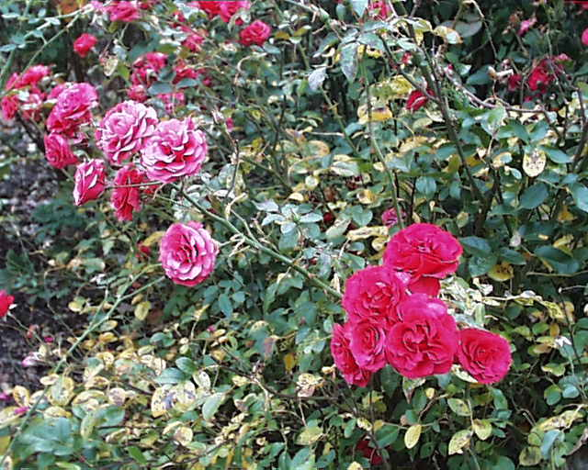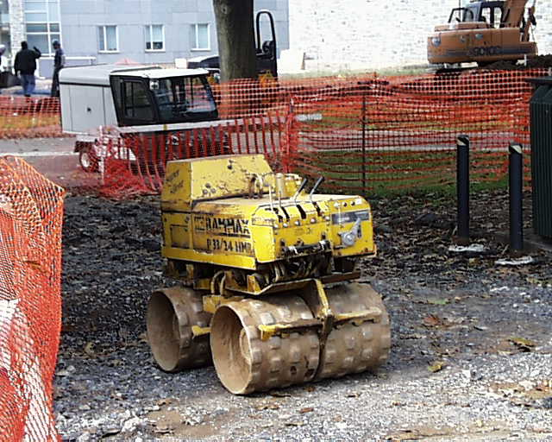

Top 3 Matches for Target Image pic.1072.jpg

Using DNN

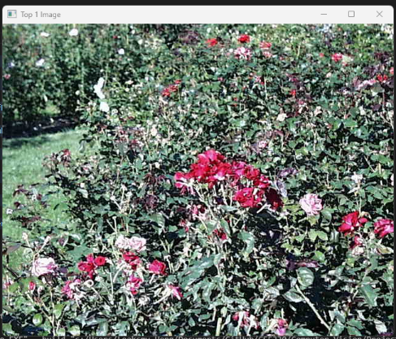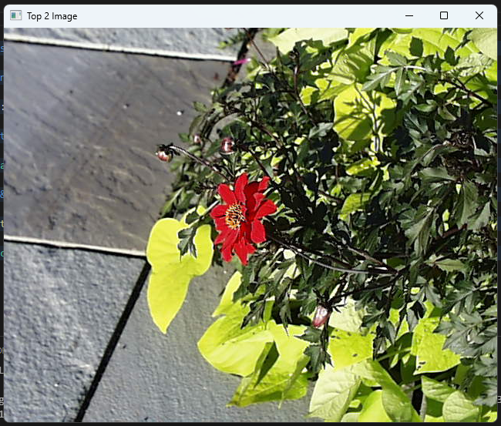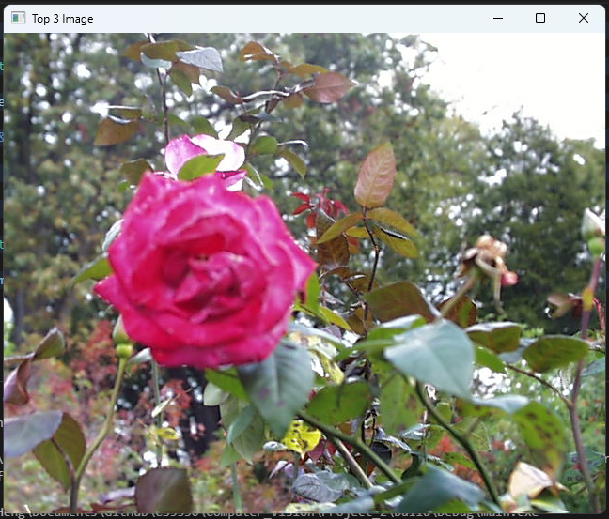

Using Color Histogram

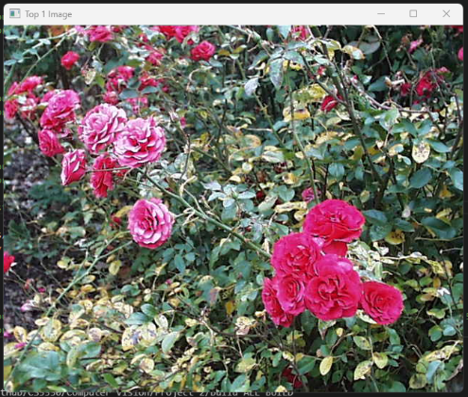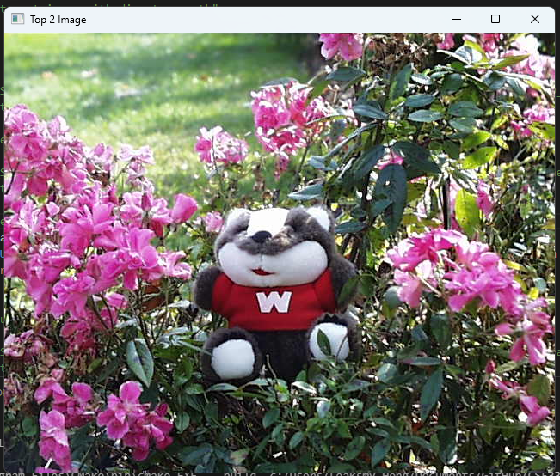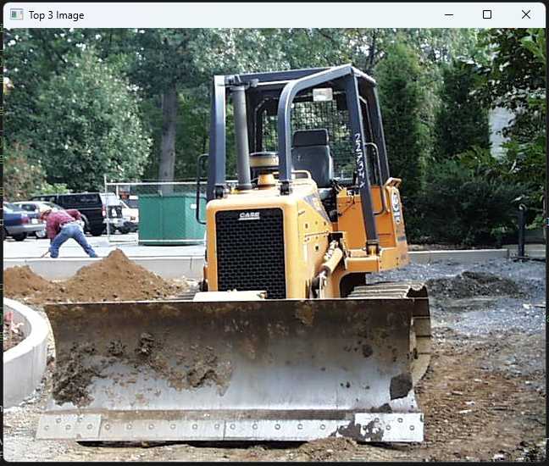

Top 3 Matches for Target Image pic.0734.jpg

Using DNN

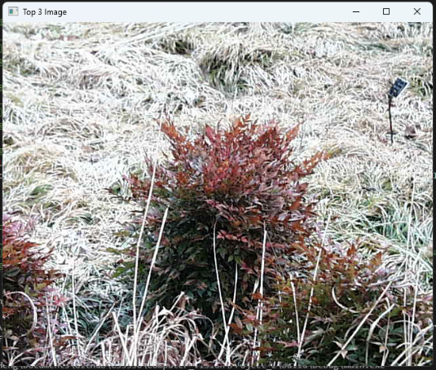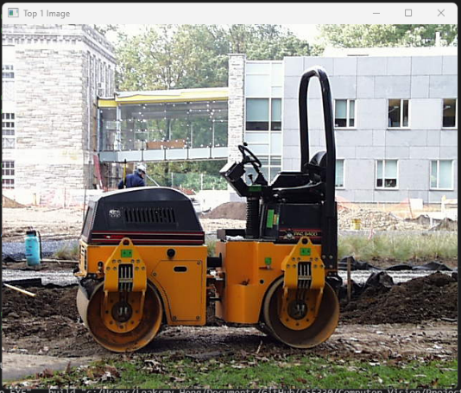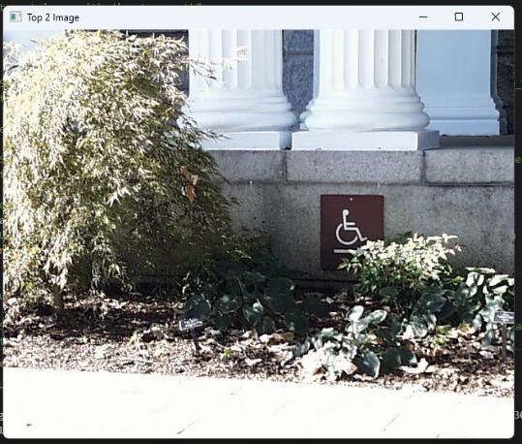

Using Color Histogram

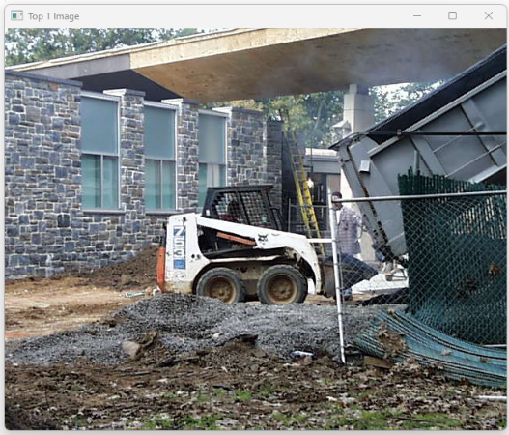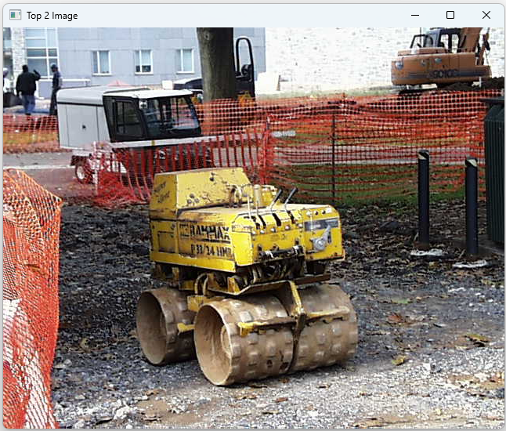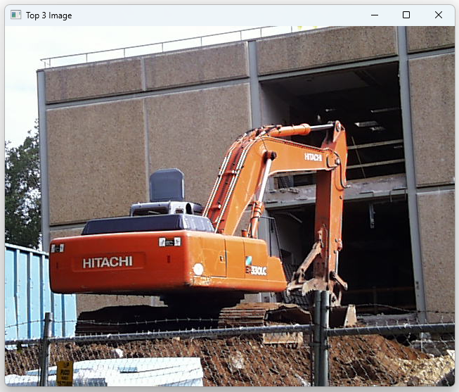

1. Custom Design

For custom design, I combined color feature with DNN. The color feature here is not the 3D color histogram we implemented in previous task. In here I extracted the color both RGB and Hue color and store it in a vector. To calculate distance metric, I applied SSD on the color feature and cosine distance for the feature from DNN. I then used give both equal weight of 0.5 and sum it together (0.5*SSD + 0.5*cosine).

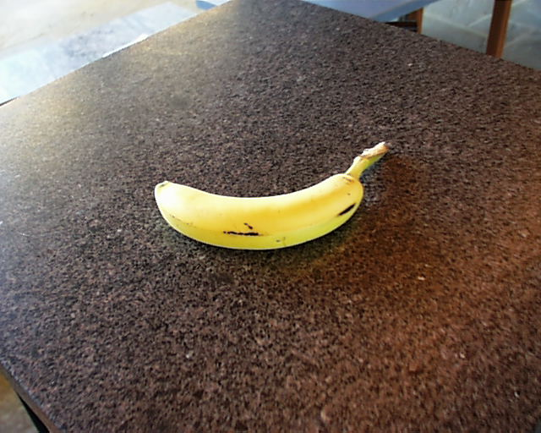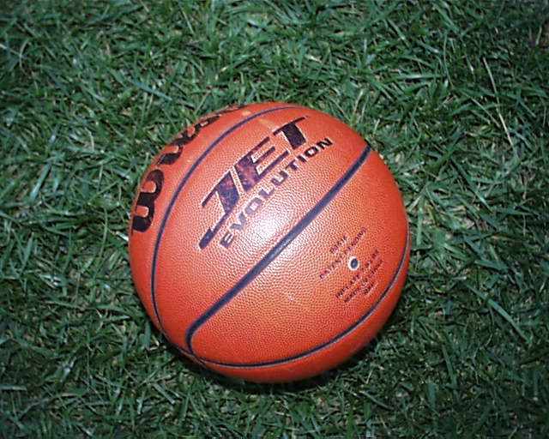Target Image pic.0280.jpg Target Image pic.0340.jpg

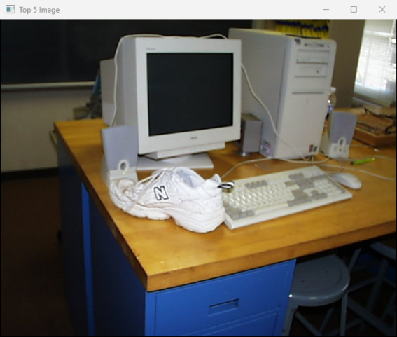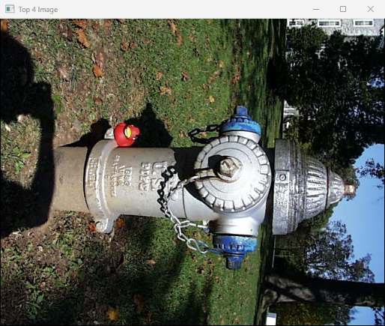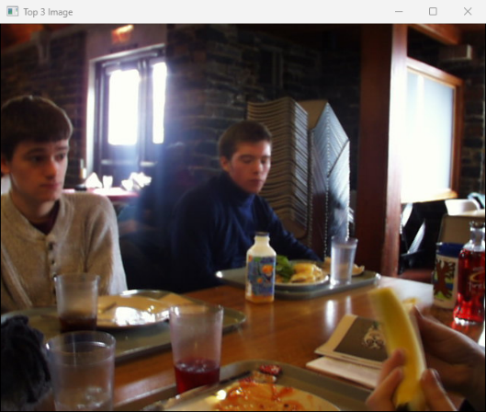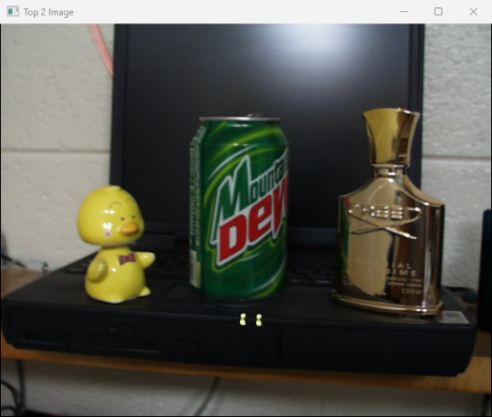Top Five Results of Target Image pic.0280.jpg

Top Five Results of Target Image pic.0340.jpg